**OUTREACH SCHOOLS EXAMINATION BOARD**

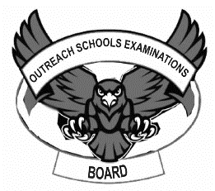 **END OF TERM II EXAMINATION 2024**

**TOP CLASS: (5 – 6 YEARS)**

**LEARNING AREA 2: LANGUAGE DEVELOPMENT 1**

**My name is: ………………………………..………………………….**

**My School is: ……………………………..……….…………………..**

**I am in: ………………………………..…………………………………………..**

1. 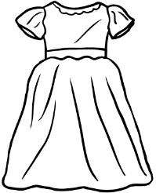**Name the pictures.**

_________________



__________________



__________________

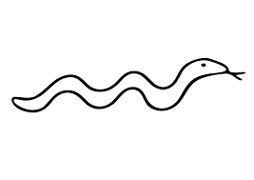 __________________

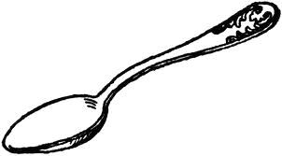

__________________

1. **Write in small letters.**

**A ______ F______**

**R______ G______**

**B______ M______**

1. **Write these words in small letters.**

BAG _________ CHAIR ____________

MAN _________ BANANA ___________

FLOWER __________ DOG _________

DUCK ___________ CUP __________

1. **Write using ‘is’ or ‘are’.**
2.  This _____ a book.

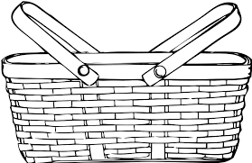

1. Here _____ a basket.

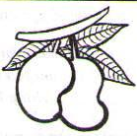

1. Those _____ mangoes.

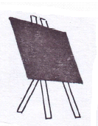

1. It _____ a blackboard.

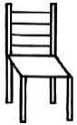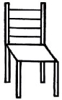

1. These chairs _____ for Nursery.
2. **Complete the story below.**

**There lived a 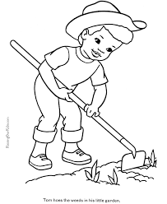____________. He planted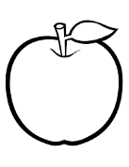 ____________ and 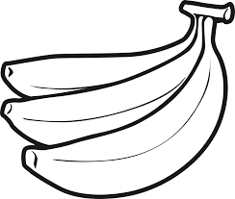____________ in his garden. He also had 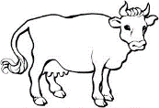_________ , 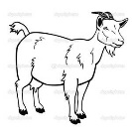_________ and 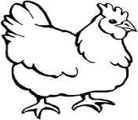__________ on his farm.**

**(man, apples, bananas, cows, goats, hens)**

**END**